**Manipal University Jaipur**

**Odd Semester 2020-21**

**Object-Oriented Programming [IT 2130]**

**LAB-1 [Introduction to Eclipse IDE and Java Basics]**

1. **Eclipse overview**
2. **Getting Started**
   1. **Installation**
   2. **Start Eclipse**
3. **Eclipse UI Overview**
   1. **Workspace**
   2. **Perspective**
   3. **Views and editors**
4. **Create your first java program in Eclipse**
   1. **Create project**
   2. **Create a Java class**
   3. **Run your project in Eclipse**
5. **Java Examples**
   1. **Example-1: Command Line Arguments (From command prompt)**
   2. **Example-2: Command Line Arguments (From Eclipse IDE)**
   3. **Example-3: Bicycle Class**
   4. **Example-4: Command-Line Arguments**
   5. **Example-5: Some Important Facts About Java Programming Language**
6. **Exercises (Write Your own Java code)**
7. **Eclipse Overview**

Eclipse is an open source community that builds tools and frameworks for creating general purpose application. The most popular usage of Eclipse is as a Java development environment which will be described in this article.

1. **Getting Started**

**2.1 Installation**

Download "Eclipse IDE for Java Developers" from its website and unpack it to a directory. This is sufficient for Eclipse to be used; no additional installation procedure is required.

* 1. **Start Eclipse**

To start Eclipse double-click on the file eclipse.exe in your installation directory. The system will prompt you for a workspace. The workspace is the place where you store your Java projects. Select a suitable (empty) directory and press Ok [See Figure-1 given below]. Don’t click and check the checkbox that says “Use this as default and do not ask again”.

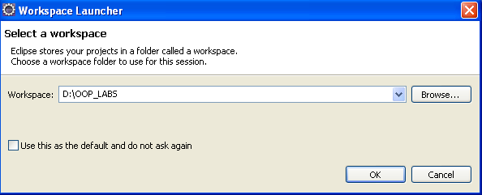

**Figure-1: Workspace Launcher**

Eclipse will start and show the Welcome screen [see Figure-2 given below].

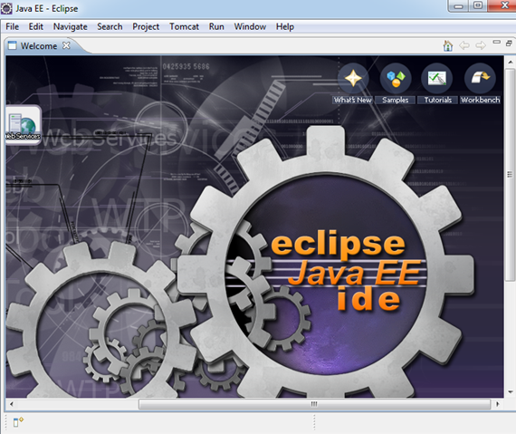

**Figure-2: Eclipse Welcome Screen**

Close the welcome page by press in little x besides the Welcome screen.

1. **Eclipse UI Overview**

Eclipse provides perspectives, views and editors. Views and editors are grouped into perspectives. All projects are located in a workspace.

**3.1. Workspace**

The workspace is the physical location (file path) you are working in. You can choose the workspace during start-up of eclipse or via the menu (File-> Switch Workspace-> Others). All your projects, sources files, images and other artefacts will be stored and saved in your workspace.

**3.2. Perspective**

A perspective is a visual container for a set of views and editors. You can change the layout within a perspective (close/open views, editors, change the size, change the position, etc.)

For Java development you usually use the "Java Perspective". You can change the layout within a perspective (close/open views, editors, change the size, change the position, etc.). Eclipse allows you to switch to another perspective via the menu (Window -> Open Perspective -> Other).

A common problem is that you closed a view and don't know how to re-open this view. You can reset a perspective to its original state via the menu (Window -> Reset Perspective).

**3.3. Views and Editors**

A view is typically used to navigate a hierarchy of information or to open an editor. Changes in a view are directly applied. Editors are used to modify elements. Editors can have code completion, undo/ redo, etc. To apply the changes in an editor to the underlying resources, e.g. Java source file, you usually have to save.

1. **Create your first Java program**

The following will describe how to create a minimal Java program using Eclipse. It will be the classical "Hello World" program. Our program will write "Hello Eclipse!" to the console.

**4.1. Create project**

Select from the menu File -> New-> Java project. Maintain "oop.eclipse.ide.first" as the project name and press the next button [See Figure-3 below].

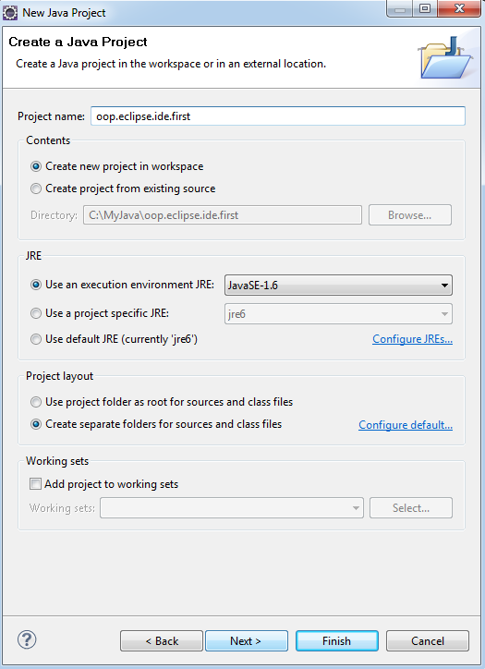

**Figure-3: Create New Java Project**

Click on the checkbox that says, "Create separate source and output folders". This generates all your .class files corresponding to the .java files in your workspace into a separate output folder.

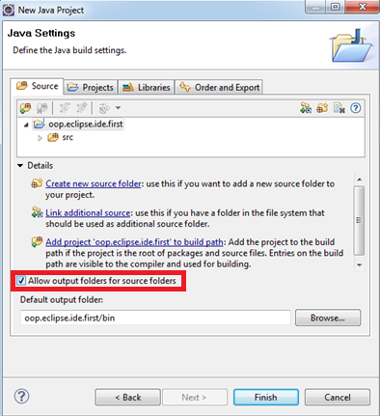

**Figure-4: Allow output folders for source folders**

Press finish to create the project. A new project is created and displayed as a folder. Open the folder "oop.eclipse.ide.first".

**4.3. Create Java class**

Right click on src and select New -> Class [See Figure-5 below]

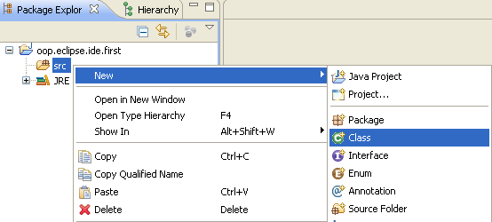

**Figure-5: Create a Java class**

Create MyFirstClass, select the flag "**public static void main (String[] args)**" [See Figure-6 below].

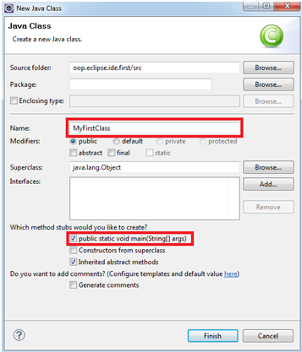

**Figure-6: Specify Class Name**

Maintain the following code.

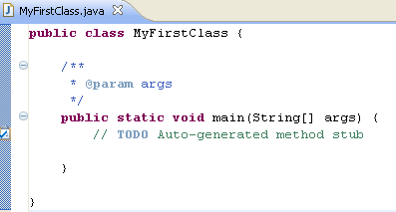

**Figure-7: Your first java program**

**Include the following statement in the *“main”* method:**

**System.out.println(“Hello Eclipse”);**

**4.4. Run your project in Eclipse**

Now run your code. Right click on your Java class and select Run-as-> Java application [See Figure-8 below].

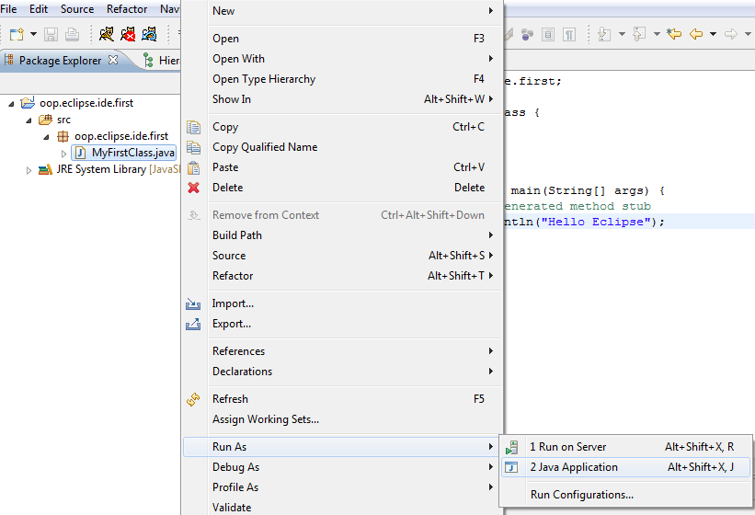

**Figure-8: Run your java program**

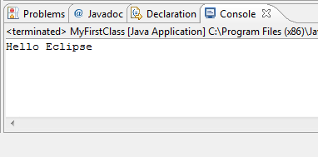

**Figure-9: Finished! You should see the output in the console**

1. **Java Examples**

**Example-1(a): Compilation and Execution of java code from command prompt**

We know that each object in java is described in terms of its states and behaviours. Also we know that an object is an instance of a class, whereas a class is a blueprint. In this example we are going to represent a real world Bicycle in Java code. We will create a class Bicycle which has three states, **speed, numberOfGears, and cadence** and it has methods to print the values of instance fields of ***Bicycle*** object.

1. Go to D Drive, create a new Text Document and name it **Bicycle.java**
2. Type the following code in this file and save the file:

**/* Bicycle class */**

**class** Bicycle {

**int** speed=100;

**int** noOfGears=5;

**int** cadence=40;

**public** **void** printState() {

System.*out*.println("Bicycle [cadence=" + cadence + ", noOfGears=" + noOfGears + ", speed=" + speed + "]");

}

**public** **static** **void** main(String[] args) {

/*create instance of Bicycle class */

Bicycle b1 = new Bicycle();

/*Invoke method object b1 of type Bicycle*/

b1.printState();

}

}

1. Click on start, go to run option, type cmd and then hit the enter key
2. Type D: on command prompt
3. Set path to run java commands as follows

To set the temporary path of JDK, you need to follow following steps:

* Open command prompt
* copy the path of jdk/bin directory
* write in command prompt: set path=copied_path

**For Example:**

set path=C:\Program Files\Java\jdk1.6.0_23\bin

1. Execute the following command

**D:\> javac Bicycle.java** [This command compiles the java code]

1. Execute the following command

**D:\> java Bicycle** [This command executes your java code]

**Example-1(b): Compilation and Execution of java code with Eclipse IDE**

1. Create the Bicycle.java class in Eclipse IDE [follow the same guidelines that are used to create MyFirstClass.java above]. Type the same java code for Bicycle class that is described in Example-1(a).
2. Run your program in Eclipse and see the output in console window.

**Example-2: Command Line Arguments (From command prompt) –**

1. Go to D Drive, create a new Text Document and name it **CommandLineArg1.java**
2. Type the following code in this file and save the file:

**/* This program expects some string as command line arguments , then it simply outputs the command line arguments to the console*/**

**class CommandLineArg1 {**

**public static void main(String[] args) {**

**for(int i=0; i<args.length; i++){**

**System.*out*.println("args["+ i +"] =" + args[i]);**

**}**

**}**

**}**

1. Execute the following command

**D:\> javac CommandLineArg1.java** [This command compiles the java code]

1. Execute the following command

**D:\> java CommandLineArg1 My First Command Line Program in Java**

This command executes your java program, the whole string “My First Command Line Program in Java”, goes as command line arguments to your java program.

**Example 3:** Write one more program [as given below], compile and execute it from command prompt.

**/* This program takes 10 integer arguments as an input from command line, parse the command line arguments to integers, finds the sum of these 10 numbers and print the sum */**

**class** CommandLineArg2 {

**public** **static** **void** main(String[] args) {

**int** sum = 0;

**for**(**int** i=0; i<**args**.length; i++){

sum += Integer.*parseInt*(args[i]);

}

System.*out*.println("Sum = " + sum);

}

}

Compile and execute this program as shown below:

**D:\> javac CommandLineArg2.java**

**D:\> java CommandLineArg2 1 2 3 4 5 6 7 8 9 10**

**Example-4: Command Line Arguments from Eclipse IDE–**

1. Create a java class file named CommandLineArguments in your workspace [Code given below].

**/* This program takes 10 integer arguments as an input from command line, parse the command line arguments to integers, finds the sum of these 10 numbers and print the sum */**

**public class CommandLineArg2 {**

**public static void main(String[] args) {**

**int sum = 0;**

**for(int i=0; i<args.length; i++){**

**sum += Integer.parseInt(args[i]);**

**}**

**System.out.println("Sum = " + sum);**

**}**

**}**

1. We can give command line arguments to our program in eclipse. For passing command line arguments to your program go to (Project->Properties->Run/Debug settings) and then in the launch configuration select your java file to which you want to pass command line arguments to [See Figure below].

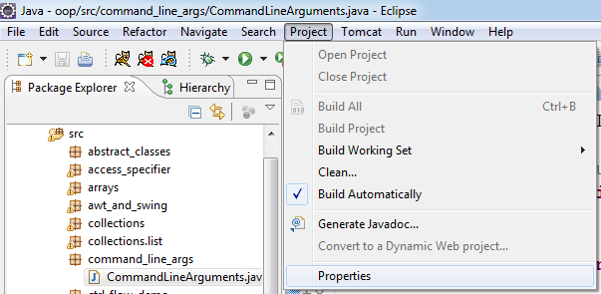

**Step-1: Select Project Properties**

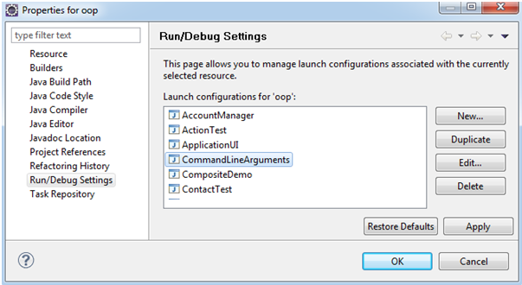

**Step-2: In Run/Debug Settings select the file CommandLineArgument and press Edit**

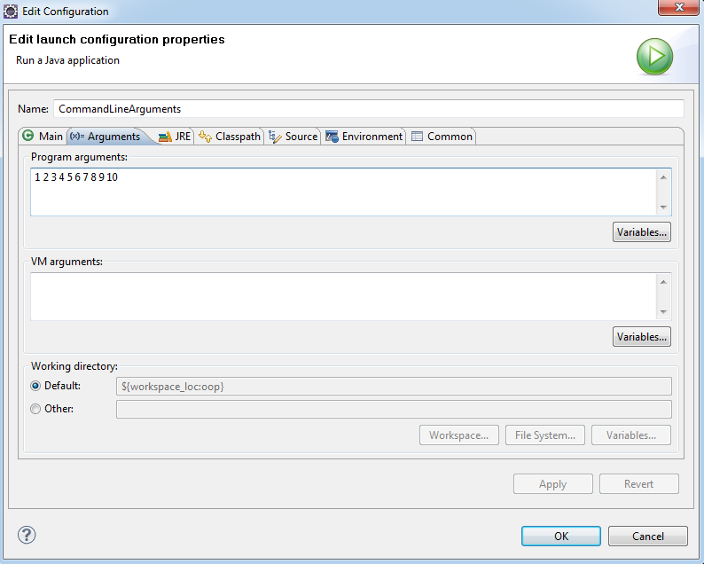

**Step-3: Select Arguments tab and enter 10 numbers separated by space then press OK**

Run the program and watch the output in the console.

**Example-5: Some Important Facts About Java Programming Language**

Consider the following class definition:

class Test

{

public static void main(String[] args)

{

**// Code Fragments**

}

}

What will be the output [Either Compile Time Error or RuntimeException] if an attempt is made to compile and execute the above java file by writing each of the following code fragments (Sr. No 1- Sr. No 6) in the main method. Observe the output and write it in the Output column.

|  |  |  |
| --- | --- | --- |
| **S.No.** | **Code** | **Output** |
| 1. | byte x = 640;  byte b=10;  b=b+1;  short s =10;  s= s+1;  char x = 1;  x = x+1;  float f = 10.56; |  |
| 2. | float x = 10.5f;  double y = 10.5;  if(x==y)  System.out.println(“Hello”);  else  System.out.println(“Hi”);  float x1 = 10.57f;  double y1 = 10.57;  if(x1==y1)  System.out.println(“Hello”);  else  System.out.println(“Hi”); |  |
| 3. | byte b = -128;  System.out.println(--b);  byte b1 = 127;  System.out.println(++b);  for(byte b=0;b<200;b++)  System.out.println(b); |  |
| 4. | byte b=(byte) 670;  System.out.println(b);  short s = (short) 40000; |  |
| 5. | if(10)  System.out.println(“Hello”);  else  System.out.println(“Hi”); |  |
| 6. | System.out.println(10+20+”10”+”20”);  System.out.println(10+(20+”10”)+”20”);  System.out.println(“10”+”20”+10+20);  System.out.println(“10”+”20”+(10+20)); |  |
| 7. | for(byte b = 0 ; b <= 200 ; b++)  System.out.println(“Hello”); |  |

**EXERCISES**

1. Write a program called **Fibonacci** to display the first 20 Fibonacci numbers F(n), where F(n)=F(n–1)+F(n–2) and F(1)=F(2)=1. Also compute their average. [ **Note:** the value 20 should be passed as a command line arguments]

The output shall look like:

The first 20 Fibonacci numbers are:

1 1 2 3 5 8 13 21 34 55 89 144 233 377 610 987 1597 2584 4181 6765

The average is 885.5

1. Write a Java program called SumDigits to sum up the individual digits of a positive integer, given in the command line.

The output shall look like:

> **java SumDigits 12345**

The sum of digits = 1 + 2 + 3 + 4 + 5 = 15

1. Write a program called **HarmonicSum** to compute the sum of a harmonic series, as shown below, where n=50000. The program shall compute the sum from *left-to-right* as well as from the *right-to-left*. Obtain the difference between these two.

http://www3.ntu.edu.sg/home/ehchua/programming/java/images/ExerciseBasics_HarmonicSum.png

**Hints:**

public class **HarmonicSum** { // saved as "HarmonicSum.java"

public static void main (String[ ] args) {

int maxDenominator = 50000;

double sumL2R = 0.0; // sum from left-to-right

double sumR2L = 0.0; // sum from right-to-left

// for-loop for summing from left-to-right

for (int denominator = 1; denominator <= maxDenominator; denominator++) {

......

// Beware that int/int gives int.

}

// for-loop for summing from right-to-left

......

// Find the difference and display

......

}

}

4. Write a program to print Nth prime number.

********* END OF LAB-1 **********